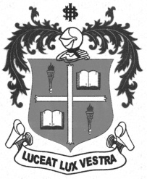
LOYOLA COLLEGE (AUTONOMOUS), CHENNAI – 600 034
M.A. DEGREE EXAMINATION - APPLIED HISTORY
SECOND SEMESTER – APRIL 2012

HT 2808 - HISTORY OF LABOUR MOVEMENT IN INDIA

Date : 17-04-2012 Dept. No. Max. : 100 Marks

Time : 9:00 - 12:00

Part-A (4x5=20 Marks)

Answer any FOUR of the following in 100 words each:

- First International Labour Commune
- Theory of Collective Bargaining
- Madras Labour Union
- Indian National Trade Union Congress
- Meerut Conspiracy Case of 1929
- Girni Kamgar Union
Part-B (2x10=20 Marks)

Answer any TWO of the following in 200 words each:

- Write a short note on the disintegration of the cottage industry in India.
- Briefly explain the Marx’s Theory of Value.
- State the impact of Russian Revolution on Indian Working Class Movement.
- Bring out the significance of Trade Union Act of !926

Part-C (3x20=60Marks)

Answer any THREE of the following in 1200 words each:

- Critically analyze the Working Class Movement in 19th Century in the World
- “Trade-Unions should be internally used for defense against assaults from outside”- Comment
- Narrate the Labour Class Movement in India between the years 1900 to 1919
- Assess the contribution of N.M.Lokande to the Working Class Movement.
- Discuss the aims and objectives of International Labour Union.
********

